Chronic Kidney Disease Prediction Model

1. Problem Statement :

Client has provided a dataset with multiple patient’s medical history data with various parameters.The requirement is to predict whether the patient is susceptible for kidney disease or not.

1. Dataset :

Columns : Parameters like Age ,BP ,RBC ., etc ( 25 Columns )

Rows : Number of Patients - 399

1. Data Pre-Processing Method :

Columns with Categorical ( Qualitative ) is converted to Nominal data & Standard Scaler method.

1. Model results :



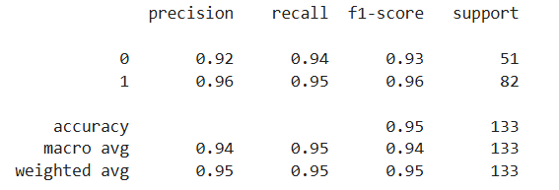

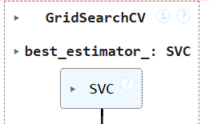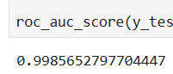

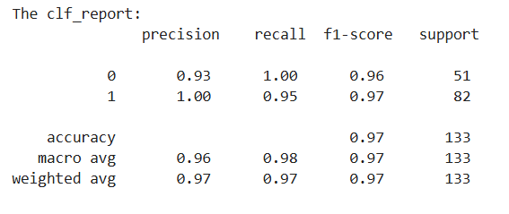



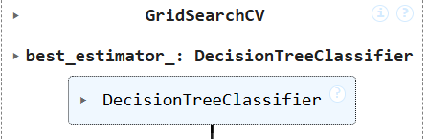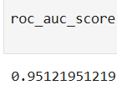



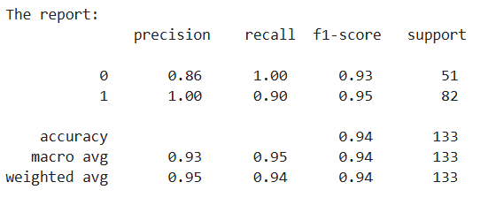

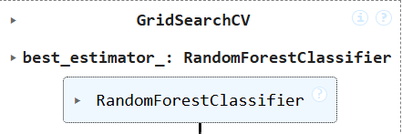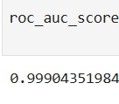

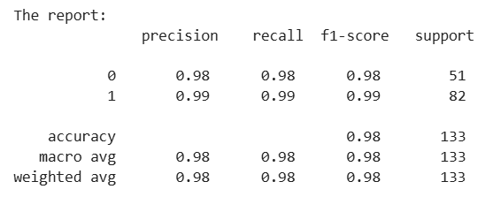

Final result :

Random Forest Classification model seems to be the best prediction model as it has the highest f1 score & Area under the curve (roc ) values.